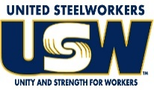
2022 Breast Cancer Awareness Shirt Sales
(KEEP THIS SHEET @ YOUR LOCAL)
Price: $20 per shirt (S-2XL)  $25 per shirt (3XL and up) |  |  |  |  |  |  |  |  | Return Orders by: August 15, 2022 to Kisha Byrd
NAME: | DEPT or TEAM | SMALL | MED | LARGE | X-  LARGE | 2X-  LARGE | 3X-  LARGE  ($25) | 4X-  LARGE  ($25) |  | 5X-  LARGE  ($25) | # OF SHIRTS | AMT DUE | PAID
Example: John Smith | Forming |  | 1 |  | 2 | 1 |  |  |  |  | 4 | $80 | PD
SHIRT SIZE TOTALS: |  | SM | MD | LG | XL | 2XL | 3XL | 4XL |  | 5XL | Total Shirts | Total Due

