2022 - 9th Annual Breast Cancer Awareness T-Shirts!
Shirts are $20 each for sizes Small-2XL, $25 each for 3XL-5XL.
All proceeds are donated to a local Susan G Komen foundation location in
place of their general fund to ensure all proceeds are used for the treatment and assistance of breast cancer patients.
This event is organized by USW Women of Steel committee
____________________________________________________________________________________________________________

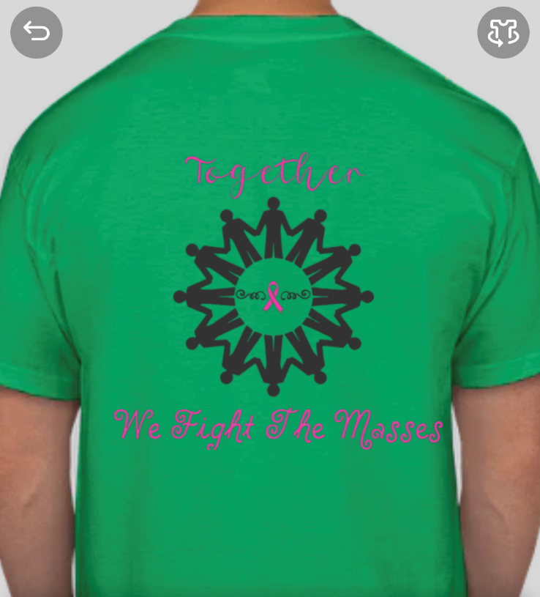

Sales will begin July 25 through August 19, 2022 All Money is due by Monday August 15th, 2022
_________________________________________________________________________________________________________________________________________________
Thank You in Advance for Your Support!

